DEVELOPMENT – COMPARISON OF REPEL METHODS
No | DESCRIPTION | CURCUIT | ADVANTAGES | DISADVANTAGES
1 | Sound  Technology: Buzzer or Loudspeaker  Cost – ~£2  Function – Generate a sound that scare unwanted visitors away  Proposed Use – Create a screeching sound that unwanted visitors believe is a predictor and are scared away | 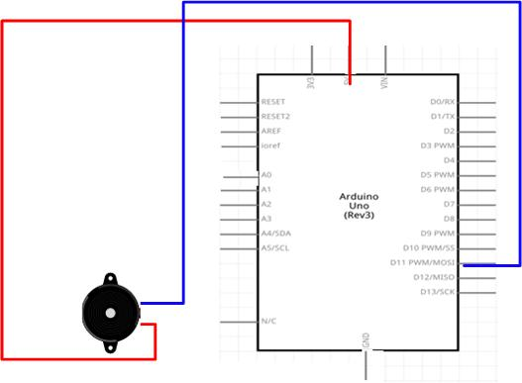 | - Simple to implement and code.  - Simple circuit – uses only one Arduino port  - SELECTED | - Buzzer may not be loud enough to scare unwanted visitors.  - Loudspeaker would require a separate power supply  - Loudspeaker would require a relay to switch power on and off
2 | Light  Technology: LED(s) or 12V Bulb(s)  Cost – ~£10  Function – Flashing lights that will scare unwanted visitors.  Proposed Use – Create a circle of flashing 12V bulbs | 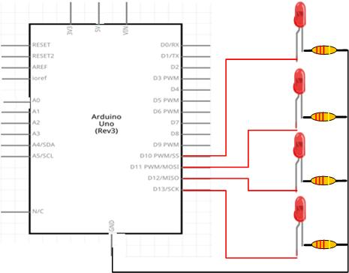 | - Would provide an impressive display | - Complex circuit and code – LEDs will use input several Arduino ports  - LEDs unlikely to be bright enough to scare unwanted visitors.  - 12V bulbs require a separate power supply  - 12V bulbs require a relay to switch power on and off  - 12v bulb solution would be the most expensive
3 | Movement  Technology: Electric or Servo motor  Cost – ~£5  Function – Electric motor could be used to make an object or pattern spin. A servo motor could be used to make an object move from side to side  Proposed Use – Use a servo motor to open a door to reveal the face of a predictor (e.g. a bird of prey) | 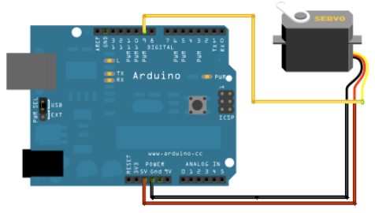 | - Simple to implement and code.  - Simple circuit – uses only one Arduino port  - SELECTED | - Motor could be exposed to rain  - Solution has moving parts that could wear out

